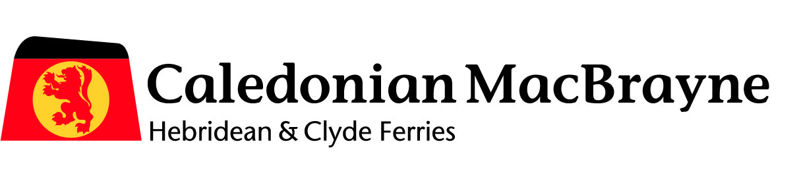
Go Explore 2015

Food and Drink Editorial 1,000 – 1,300 words
- Double page editorial featuring food and drink information from around the Clyde and Hebridean islands. Focus on local produce, production and ‘farm to fork’ process.
- Food for all – something to suit all tastes
- High quality, fresh produce is available all over the islands and destinations we serve
- Case studies – snippets of information about local producers ie. Barra Atlantic supply top restaurants in London
- Background to how the food is reared/made/cooked – cultural traditions
- Testimonials and statements from local producers ie. farmers
- Round it off with how CalMac are involved in the production/sales process in transporting the produce and stocking local produce and ingredients onboard.
- Did you know – info bites

Please include images to support text
Format
- Lifestyle magazine

Eating out and where to buy local produce guide 200 words per region (5)
- This section will be placed amongst the regional content. A separate piece will be required for each region: Kintyre and Clyde, Southern Hebrides, Inner Hebrides, Skye Raasay & the Small Isles, Outer Hebrides,
- Each region should have a section with a description on the top places to eat around the islands – everything from restaurants, to chip shops to ice cream parlours. Include information on where to buy local produce – i.e., Arran Cheese Factory.

Please include images to support text

Please see our current stock list of local retail products attached

